1. What factors do you need to take into consideration before deciding if Dragonpay is suitable to your business?
First, SECURITY. Security is a great factor for me as a merchant in choosing which payment system to consider when establishing an online store.
Second, MODE OF PAYMENT. With DragonPay’s multiple payment modes, it gives a big factor for me as a merchant to consider this payment system in establishing an online store. Most of the online customers are afraid to purchase online due to the “Credit Card Only” mentality. With DragonPay, there are plenty of ways to pay your orders online. DragonPay does not only offer credit card transaction but also for Over-The-Counter on banks with wide network, and Online Payment method.
Third, SET UP FEE. Comparing to other payment systems, DragonPay offers a low set up fee. For starters, it is a great help.

2. Try the Dragonpay service as a payment option and make a purchase. Document your experience.
I have purchase a domain via DOT.PH for starbooks.ph and I used DragonPay as my payment method. After filling up the entire necessary requirement at the DOT.PH website on acquiring the starbooks.ph, I was redirected to the DragonPay portal for the payment.
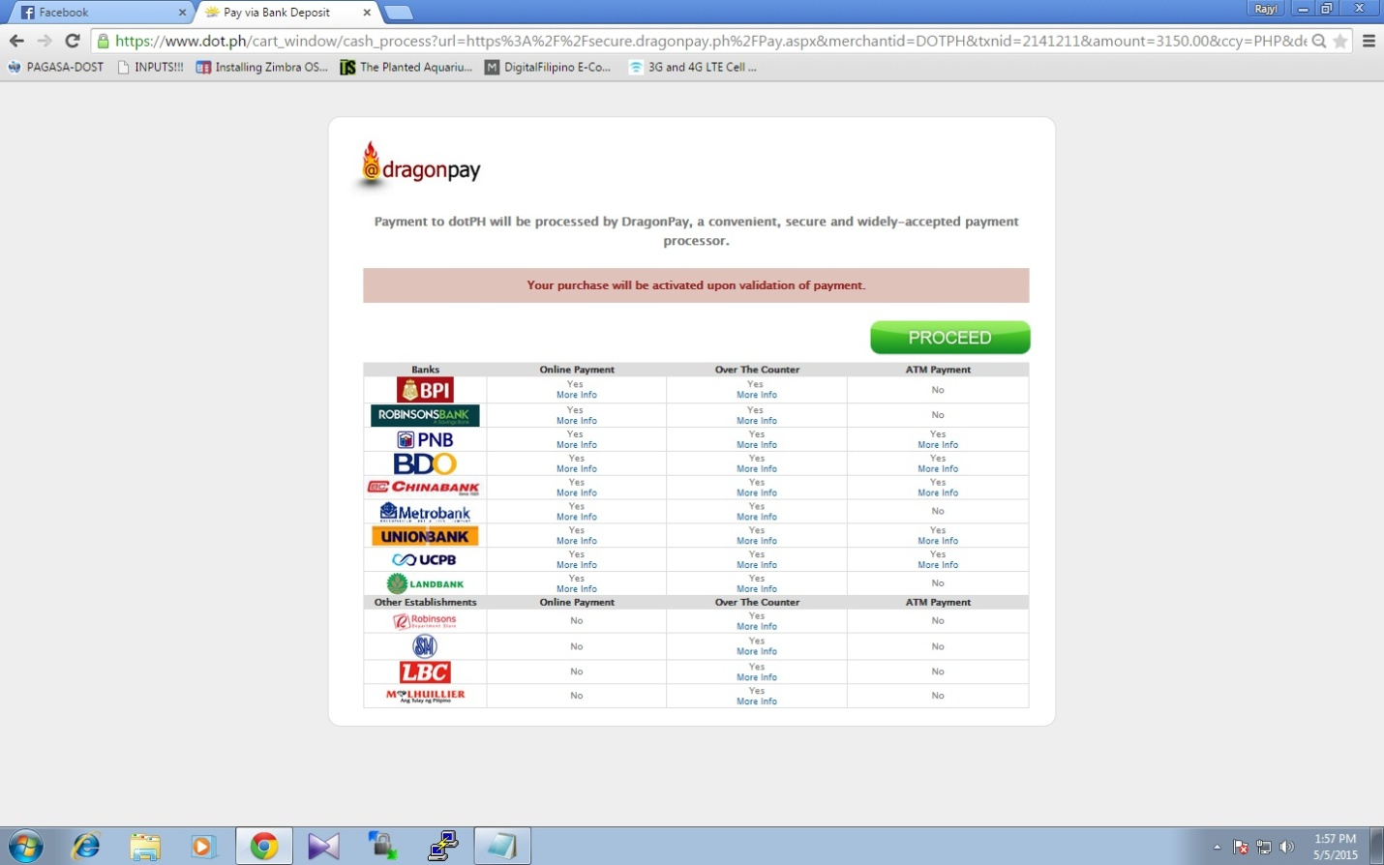

As instructed to proceed, I then selected the LANDBANK OVER-THE-COUNTER type for my payment.
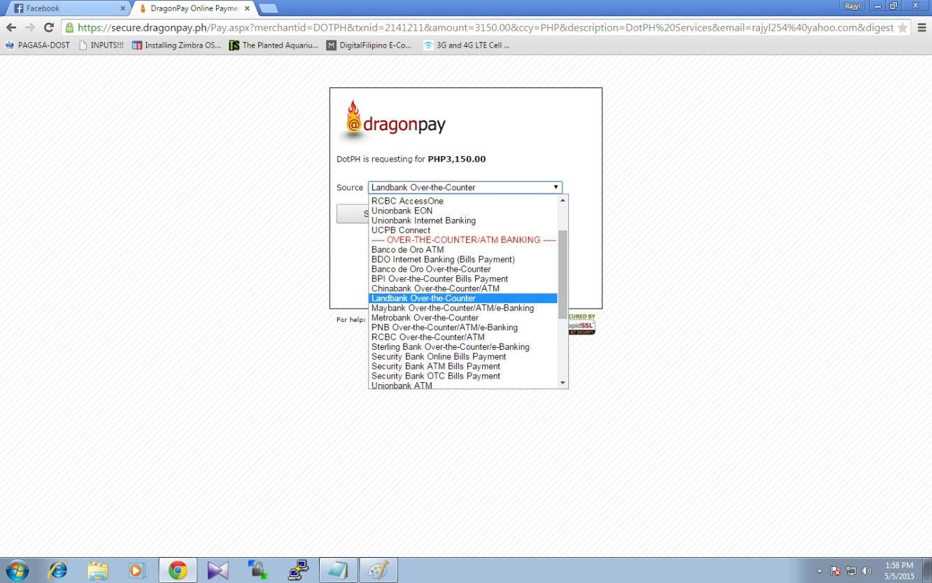
An instruction was given saying that I should deposit my payment over-the-counter at any Landbank branch until the next day.
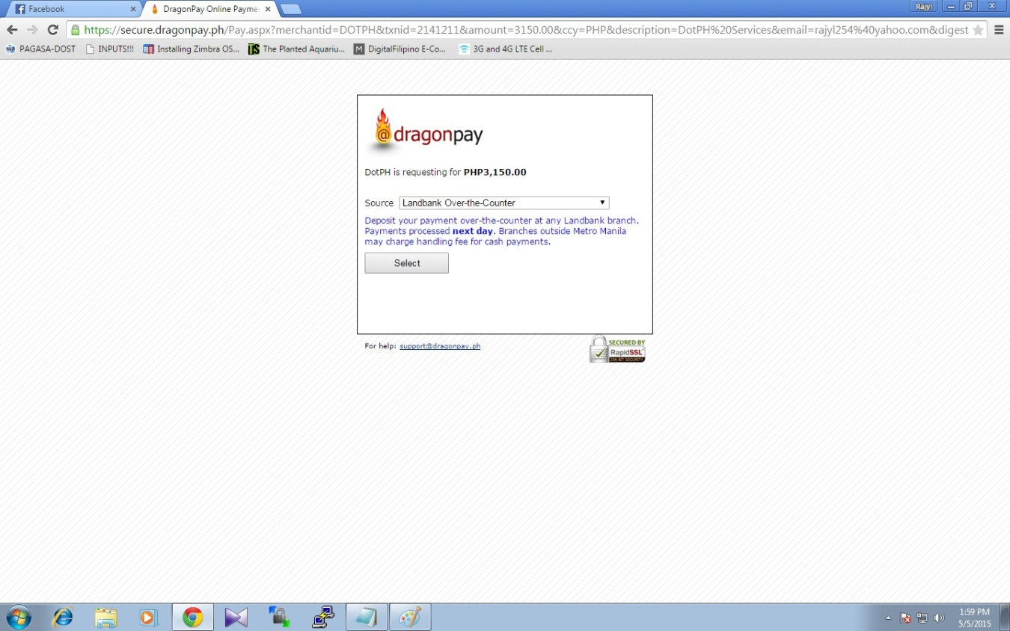
A reference number with the amount was indicated. I need to provide my email for the payment instructions to be sent.
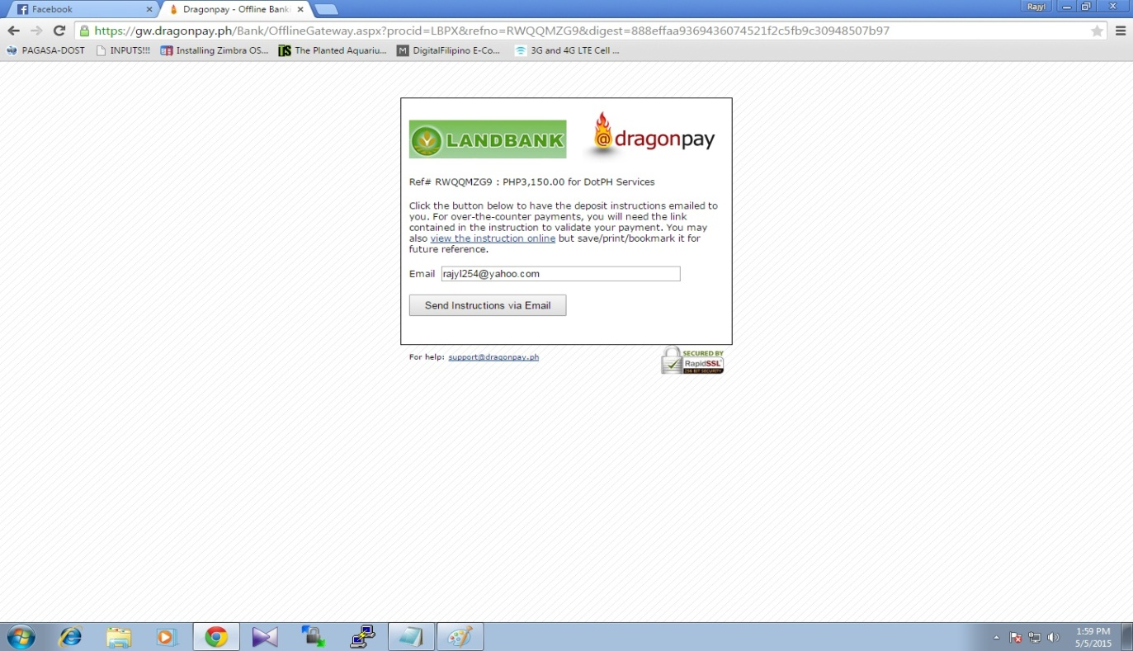
After filling up the email, I was redirected to DOT.PH for the confirmation. Informing again with the reference number, the amount and the domain that I am about to purchase.
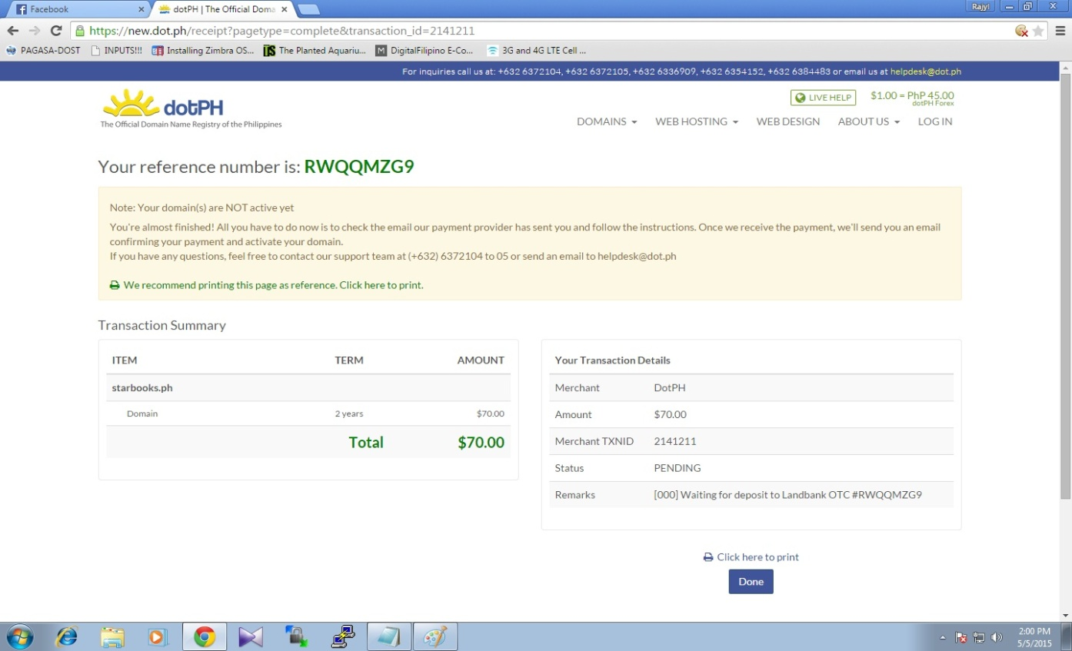
Upon checking my email, a link was given to me for the instructions in paying my purchase thru Landbank Over-The-Counter.
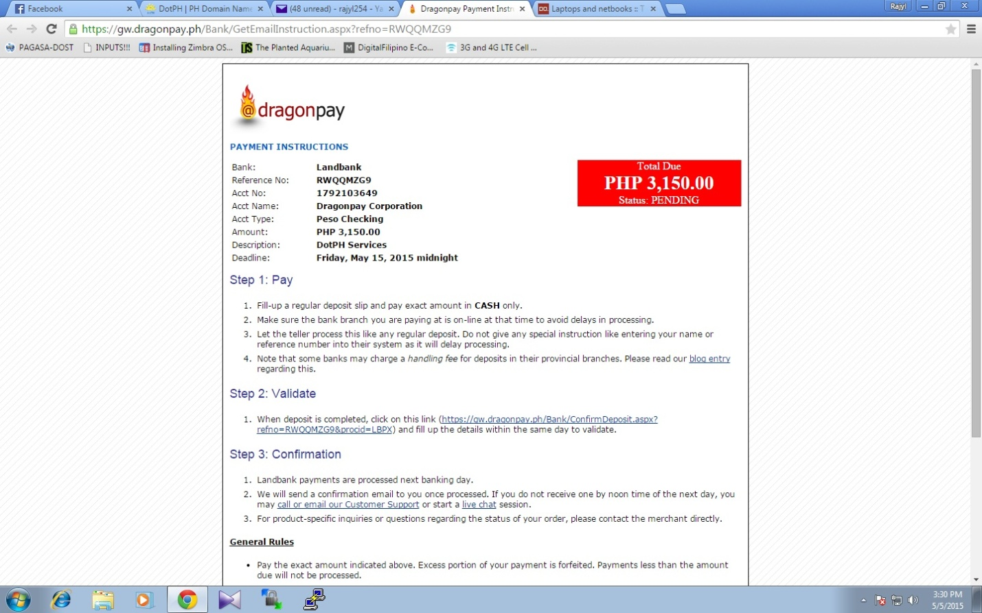
Now, paid the purchase and transaction was done.
3. In comparison to MePay, which was more convenient for you to use as a consumer?
As a customer, the easiest way for me is the MePay. With just one log in and confirmation, the order was done with utmost security features. Probably if MePay can invite more merchants, it will great for customers to use it.
The DragonPay system somewhat the old school process wherein it is too long and too risky filling up all those text box (though it runs in a SSL socket but we can’t eliminate the key loggers).
4. From a merchant's point of view, how would the two (MePay and Dragonpay) compare?
MePay and DragonPay differ greatly. One of which to mention is the available mode of payment when purchasing. DragonPay does not only offer credit card transaction but also for Over-The-Counter on banks with wide network, and Online Payment method.

