1. Create an account at https://mepay.ph/ and shop in one of its accredited shops.
Account name: 09205582958
Linked SMART Money: 5299 6757 9343 5106
Accredited Shop: Zalora

2. Document the experience by adding screenshot.

BUYING AT ZALORA USING MEPAY
A. My Zalora Cart. This is the product I want to purchase from Zalora.
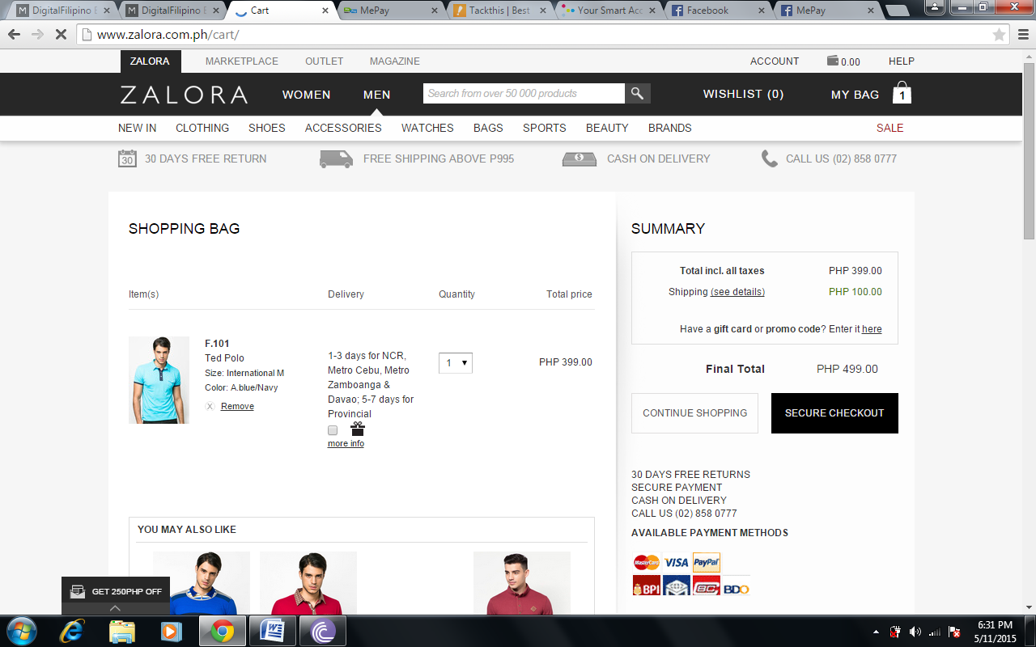
B. Choosing MePay as payment.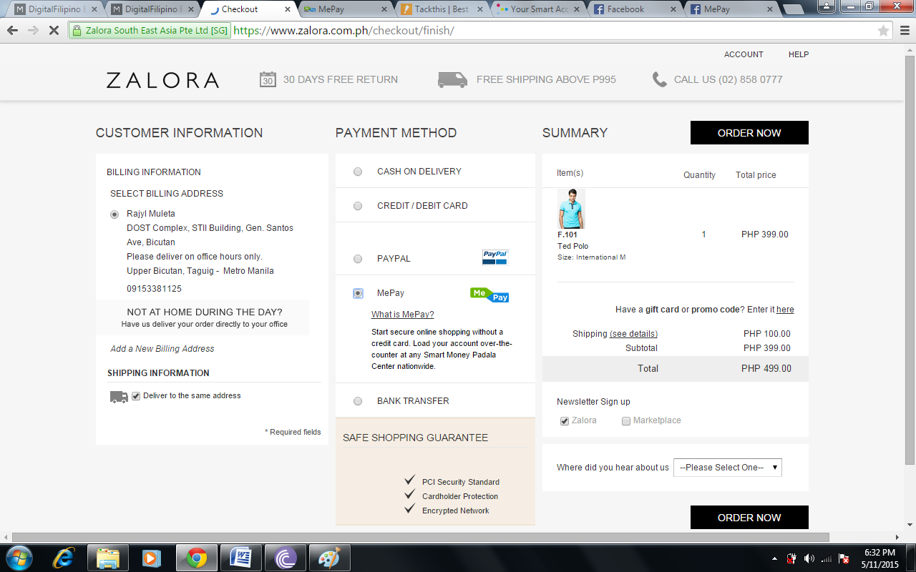

C. After choosing MePay as my payment method, the system automatically linked me to MePay Login to confirm my order.
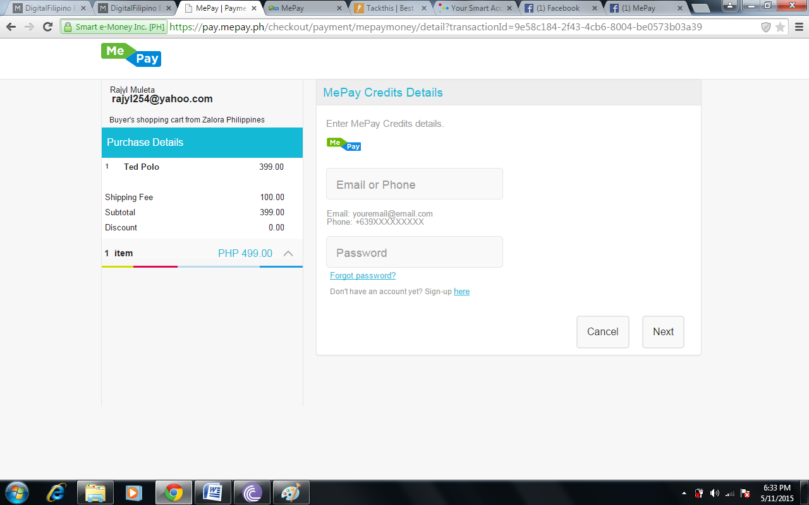
D. Filled up all the necessary login process.
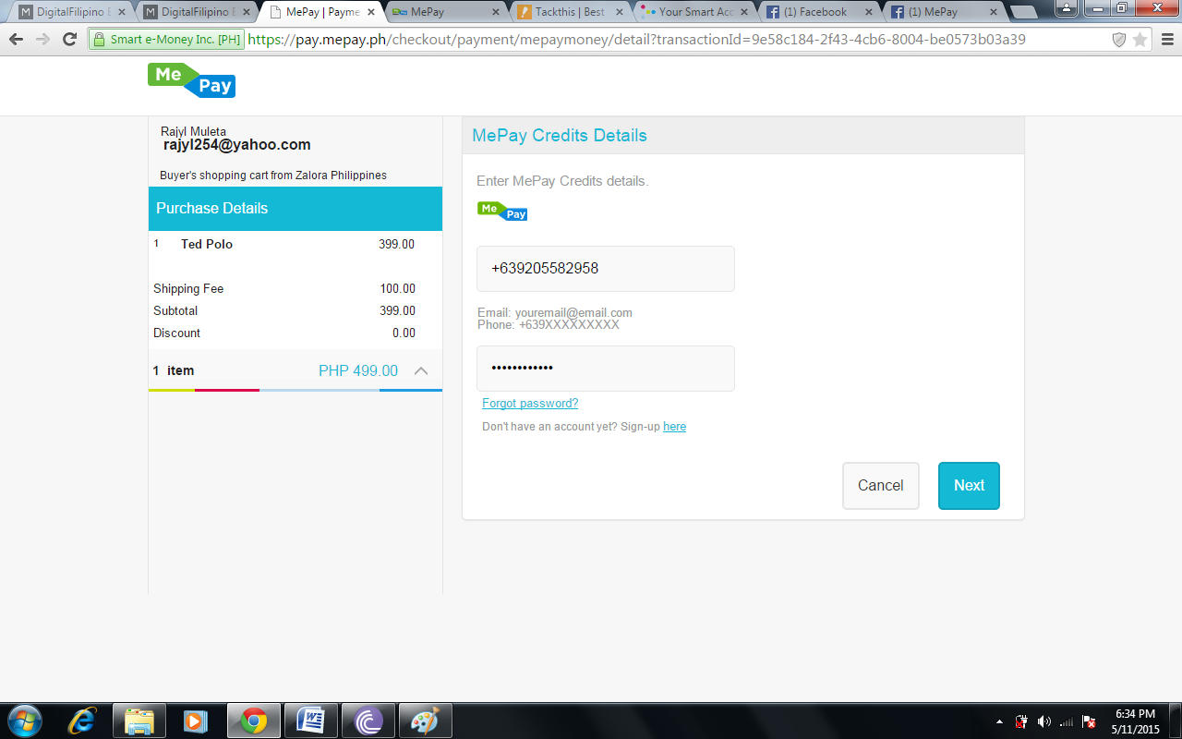
E. Confirmation
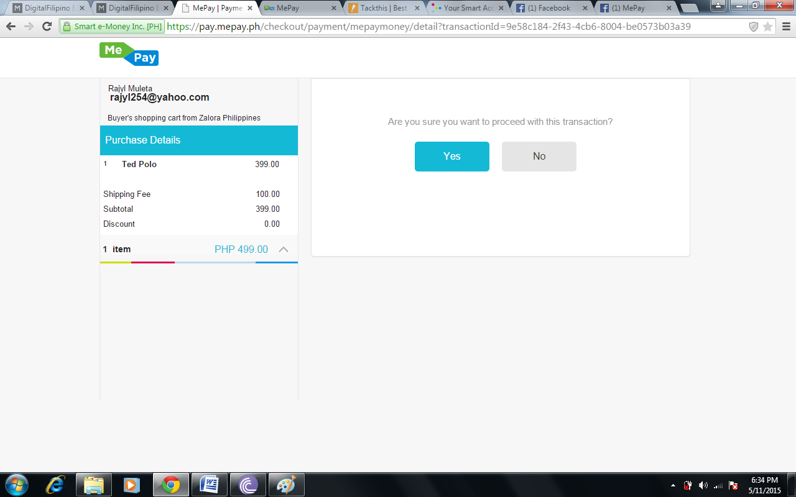

F. A text notice was sent to my SMART Mobile Number announcing my order with Zalora containing the amount, reference number and merchant reference number. With enough MePay Credits, system will confirm that the order is being made.
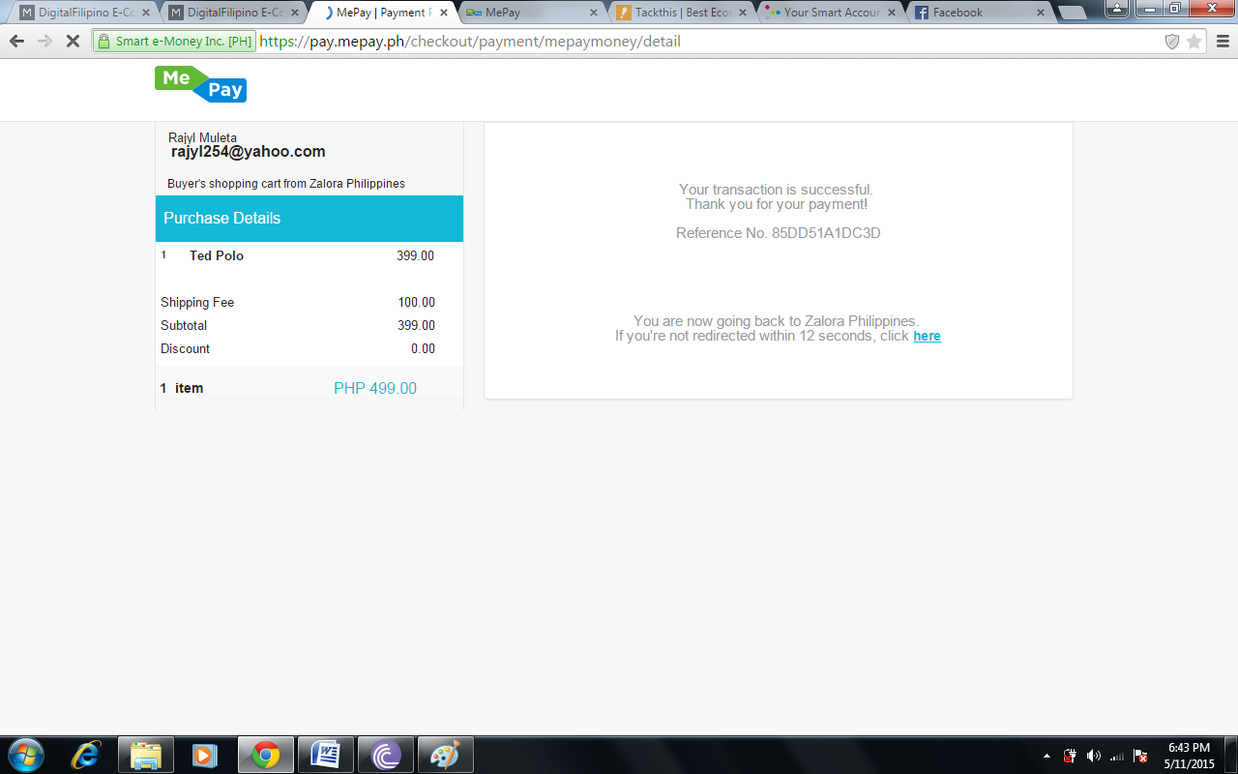
G. Notification from Zalora that the order was successful. 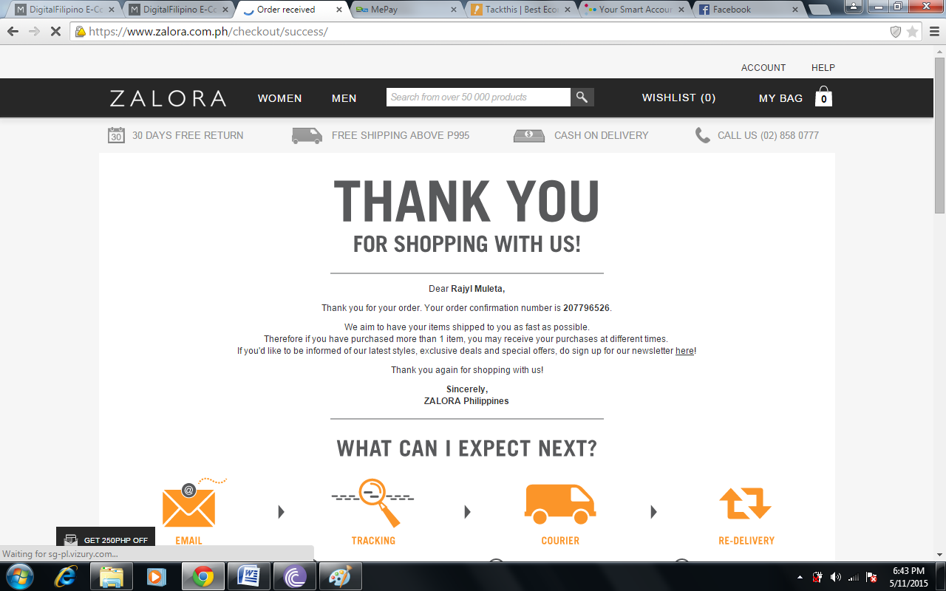
G. Checked on my Zalora Account, using its order tracking feature, order was successfully done using MePay. 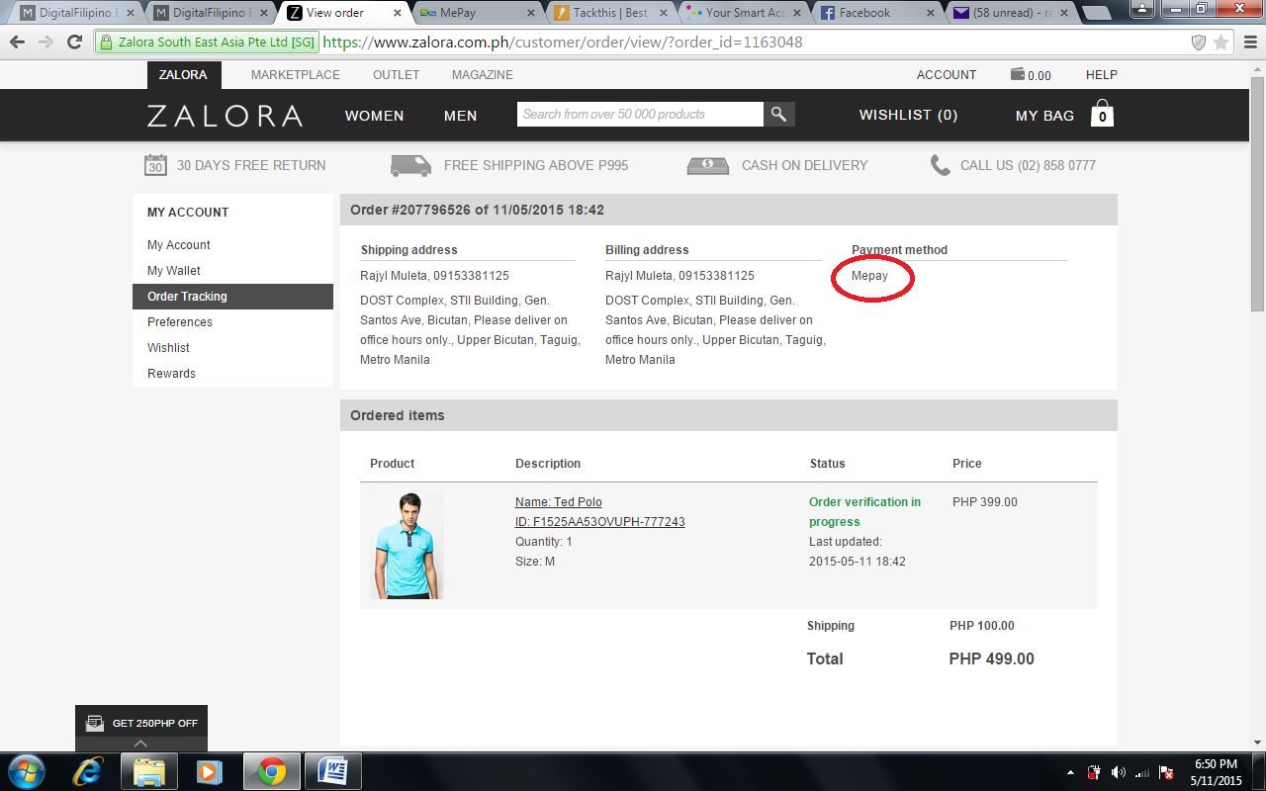
LOADING THE MEPAY ACCOUNT USING SMART MONEY
After a successful link of the MePay and the Smart Money Account, a text was sent to my Smart Mobile Number confirming the transaction with the amount, the Smart Mobile number and the Smart Money account that it was successfully loaded to MePay. Accessing it on the web, the amount loaded will be shown on the MePay Credit.

- Successfully linked the SMART Money Account to MePay. 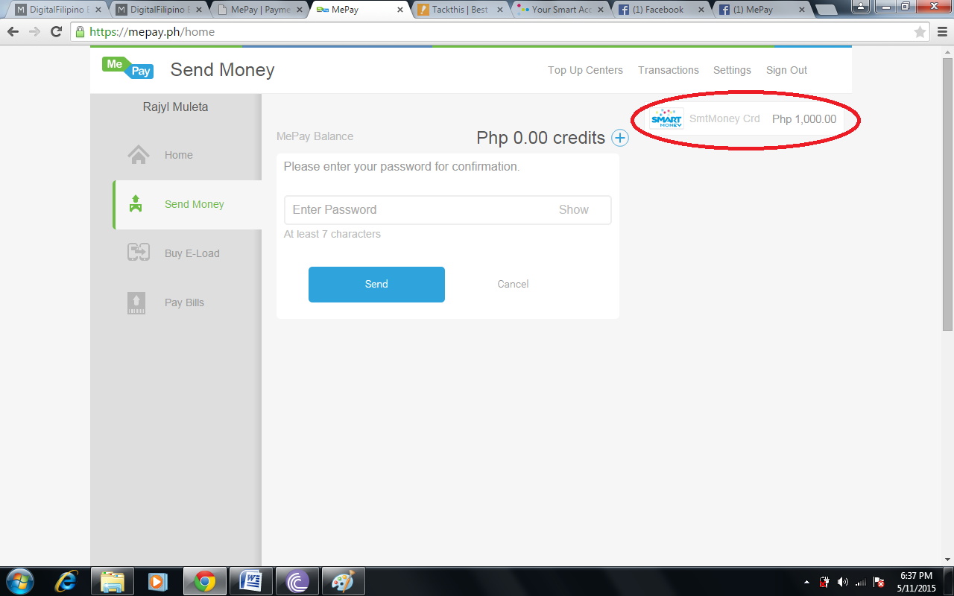
- Transferring credits from Smart Money to MePay.
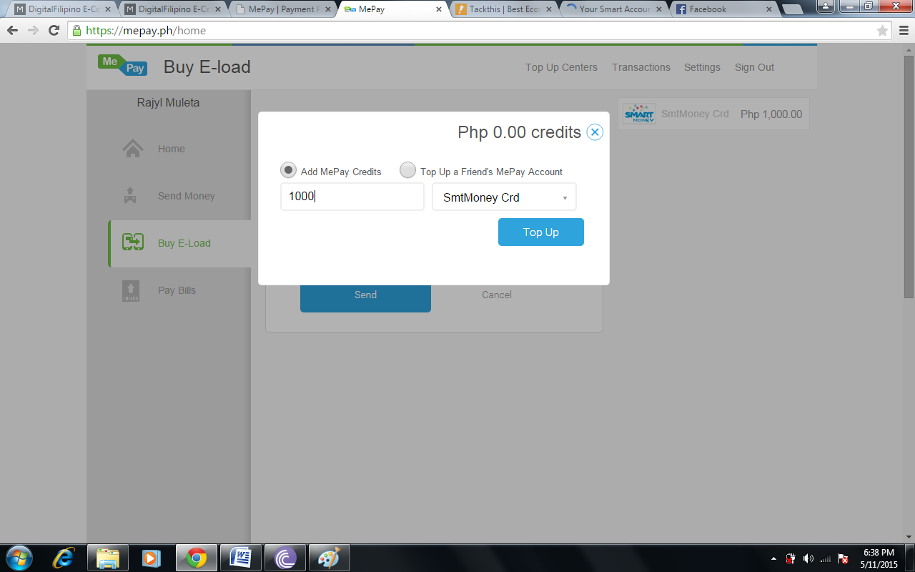
Note: Topping up my Smart Money to MePay cost me 2.50Php on that transaction. So, I change the value to 900Php.

- Successfully transferred credit to MePay from Smart Money. Notice the 900Php Credits automatically reflected on my MePay Credit.
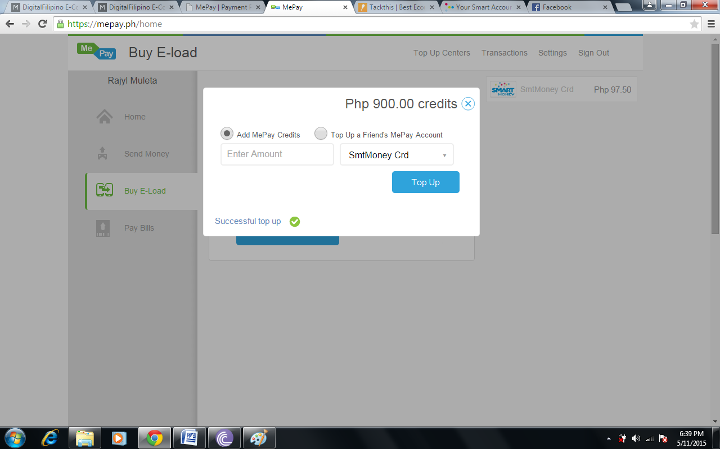
A text message was sent to my Smart Mobile Number notifying me that I have successfully transferred 900Php to my MePay account. SUCCESS! :D

3. In your last 2 slides, answer the following questions:
A. Share your point of view on the shopping experience.
The Smart Money System is a bit hassle on the beginning. Linking your Smart Mobile Number, Smart Money Account and the MePay system is a bit tedious and complex. Once done, this is a great break through on technology since everything is being catered at ease on your fingertips.

Buying through MePay is really great. It eliminates the hassle on filling up all those text fields and captcha just to be verified. And with all the notifications being sent to my mobile number and email, this features made my MePay experience great since transparency and security is a great factor for me especially on buying and accessing online transactions.

B. From a merchant's view, what work well? What challenges do you think the merchant has to deal with in processing your order?
The PROS:

- Ease of purchasing items online. You do not need to fill up a lot of identification requirements just to be verified by the system in order to buy something. In this way, it will give the customer the opportunity to buy with ease. Since the system informs you with your mobile number and your Smart Money Account, Email and your MePay system, it is transacting with transparency.

- There are a lot of ways to load credits to these accounts. Depositing money via BDO bank, Smart Money Padala and over the counter on any Smart Centers.

The CONS:

- Linking your accounts. It is indeed a hassle to link these accounts. With the strict feature of the Smart Mobile and Smart Money (Lock-Unlock), it is a pain to have these account linked by your own. Though the Smart Attendants are very willing to help you get through the process.

- Smart Mobile operations. Inquiring, unlocking, and other transaction via SMART Menu has a transaction charge of 2.50Php. Which I assume it doesn’t, that’s why my load was drained not knowing that it has a transaction fee. Having to do these operations (which you will be doing most of the time without internet access) can be expensive in the long run.

- Transferring credits. Though there are a couple of means to load credits to your Smart Account and or MePay, it is a bit of a downfall to load credits to MePay because I don’t have the luxury to go to malls in order to visit top up centers. Next, using the Smart Money Account for me cause

